**Guided Capstone Project Report**

Based on the analysis of the available data of the various resorts located in numerous states, I would like to recommend increasing the adult weekend ticket price to recoup the increased operational cost.

The distribution of the current adult weekend ticket price is shown in Fig.1. This distribution shows that we have a room to increase ticket price if this helps to solve the problem.

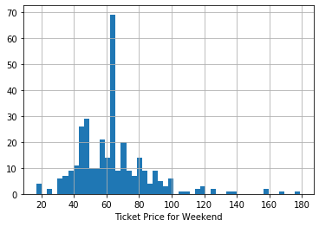

Big Mountain Ticket Price: **81**

Fig 1: Distribution of Adult Weekend Ticket Price

Predicted price of the adult weekend ticket based on the resort’s current features is $89.33. Hence, resort can increase the ticket price immediately. Comparison of predicted price and actual price is shown in Figure 2.

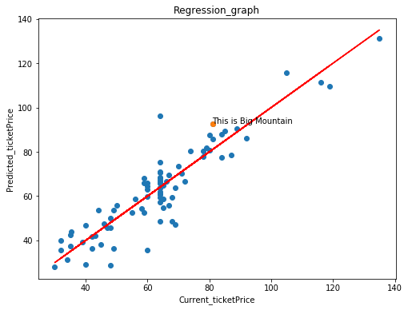

Fig 2: Predicted price vs current price

To further increase the price of the ticket, management should focus on improving the features like: ‘fastQuads’, ‘SkiableTerrain_ac’, ‘Nightskiing_ac’. Adult Weekday Price highly depends on these features. Their dependence is shown below in Figure 3.

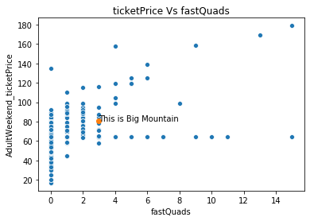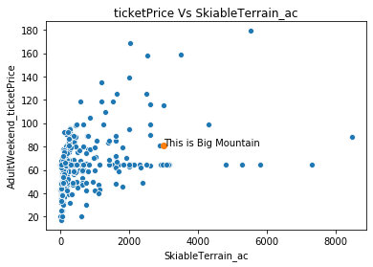

Fig 3: Ticket price vs SkiableTerrain_ac and fastQuads

**Methods**

Two Multinomial linear regression models were fitted. First model considering all the features shows the high dependence of the location of the resort, which can’t be controlled by the managers. Hence, second model was fitted by excluding the inherent factors: 'state','summit_elev', 'vertical_drop', averageSnowfall', 'yearsOpen', 'daysOpenLastYear', 'projectedDaysOpen'. Both the model performance metrices: explained_variance_score and meas_absolute_error is improved in the second model.